SPRINT-2

|  |  |
| --- | --- |
| Date | 5 November 2022 |
| TEAMID | PNT2022TMID48639 |
| ProjectName | IoTBasedsmartcropProtectionsystemforagriculture |
| Maximummark | 20marks |

STEP1:DownloadandInstallNODEJS.

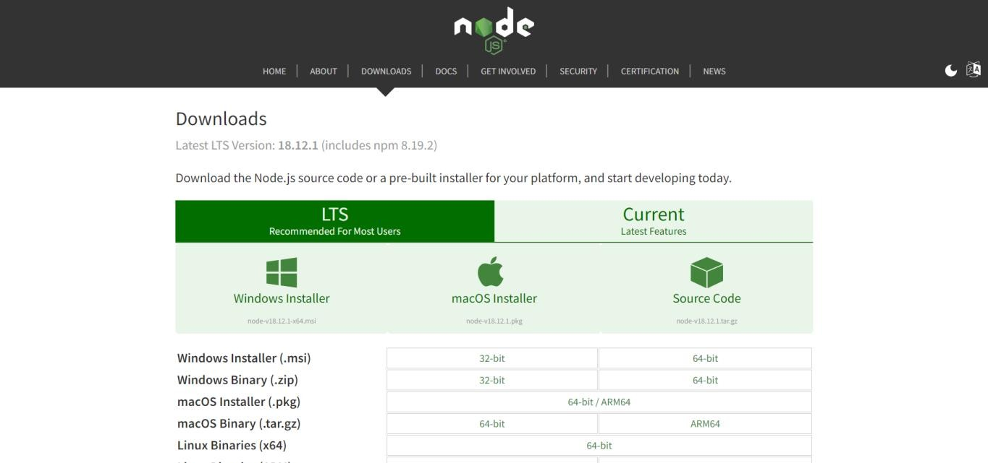

STEP2:Setupnode.jsandconfigurecommandpromptforerrorcheck.opennode-redfromthegeneratedlink.

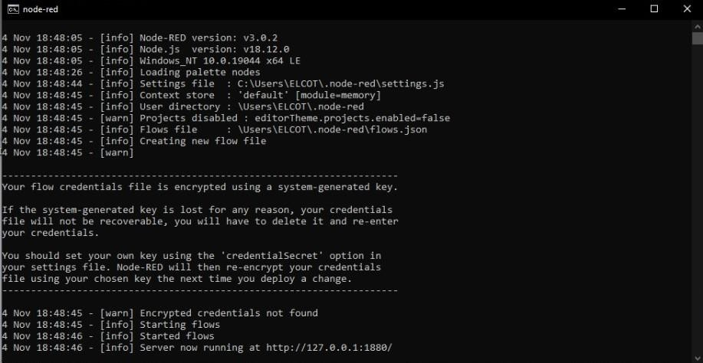

STEP3:Connect IBMIOTinandDebug1andDeploy.

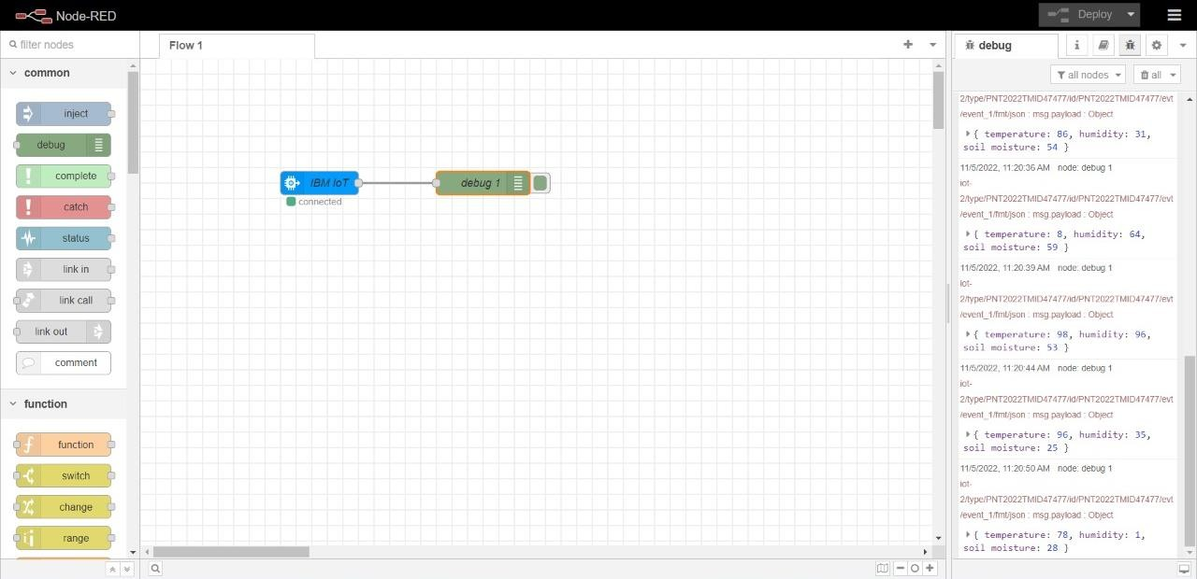

STEP4: Edit gauge node (Here the gauge nodes are named as Temperature, Humidity and Soilmoisture).

